Template for Evidence(s)
UI GreenMetric Questionnaire

University : ...
Country : ...
Web Address : …
SAMPLE
[2] Energy and Climate Change (EC)

[2.9] Elements of Green Building Implementation as Reflected in All Buildings (EC.6)
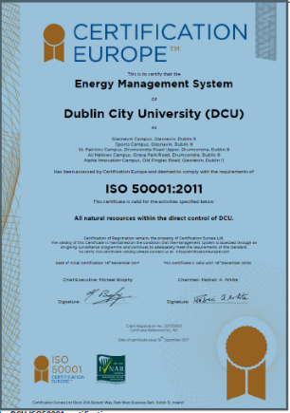
Example of Green Building Implementation - Copy of the DCU ISO50001 certification (Dublin City University, Ireland )
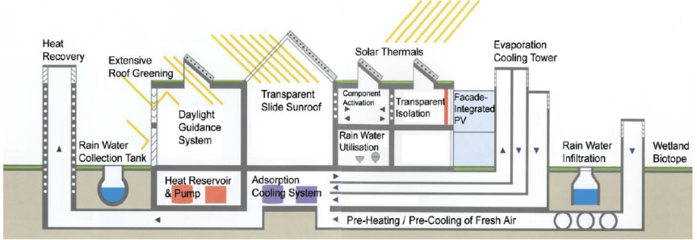
Example of Green Building Implementation - Overview Green Technologies implemented at the Environmental Campus Birkenfeld (Umwelt-Campus Birkenfeld, Germany)

GBI Non-Residential Existing Building | Building A | Building B | Building C | Building D | Building E | Building F
Element 1. Energy Efficency | V | V | V | V | V | V
Design & Performance
Minimum EE Performance
Lighting Zoning
Electrical Sub-metering |  | V |  | V |  | V
Renewable Energy | V | V | V | V | V | V
Advanced or Improved EE Performance - BEI
Commissioning
Enhanced or Re-commissioning
On-going Post Occupancy Commissioning
Monitoring, Improvement & Maintenance
EE Monitoring & Improvement
Sustainable Maintenance | V | V | V | V | V | V
Element 2. Indoor Environmental Quality | V | V | V | V | V | V
Air Quality
Minimum IAQ Performance
Environmental Tobacco Smoke (ETS) Control
Carbon Dioxide Monitoring and Control | V |  |  | V |  | V
Indoor Air Pollutants
Mould Prevention
Thermal Comfort
Thermal Comfort: Controllability of Systems
Air Change Effectiveness
Lighting, Visual & Acoustic Comfort
Daylighting | V | V | V | V | V | V
Daylight Glare Control |  | V | V |  | V
Electric Lighting Levels | V |  |  | V |  | V
High Frequency Ballasts
External Views | V |  | V |  | V
Internal Noise Levels
Verification
IAQ Before/During Occupancy
Occupancy Comfort Survey: Verification
Element 3. Sustainable Site Planning & Management |  | V |  |  | V
Facility Management
GBI Rated Design & Construction
Building Exterior Management
Integrated Pest Management, Erosion Control & Landscape Management
Transportation
Green Vehicle Priority - Low Emitting & Fuel Efficient Vehicles |  | V |  |  | V
Parking Capacity
Reduce Heat Island Effect
Greenery & Roof |  | V |  |  | V
Building User Manual
Element 4. Materials & Resources | V | V | V | V | V | V
Reused & Recycled Materials
Materials Reuse and Selection
Recycled Content Materials
Sustainable Materials & Resources and Policy
Sustainable Timber
Sustainable Purchasing Policy
Waste Management
Storage, Collection & Disposal of Recyclables | V | V | V | V | V | V
Green Products
Refrigerants & Clean Agents
Element 5. Water Efficiency | V | V | V | V | V | V
Water Harvesting & Recycling
Rainwater Harvesting | V | V | V | V | V | V
Water Recycling |  | V |  | V | V
Increased Efficiency
Water Efficient - Irrigation/Landscaping | V |  | V |  | V
Water Efficient Fittings
Metering & Leak Detection System
Element 6. Innovation
Innovation & Environmental Initiatives
Green Building Index Facilitator

Description:
(Please describe the elements of green building implementation on your campus. The following is an example of the description. You can describe more related items if needed.)

- Dublin City University gained ISO 50001 certification – also attached is DCU’s construction and renovation policy.
All buildings of the Environmental Campus Birkenfeld fulfil the requirements of the European and German Energy Standards for Buildings, whereby some reach much higher standards. ECB implemented the elements of ‘green building’ such as an adsorption cooling plant for cooling purposes, a geothermal heat exchanger to pre-warm the outside air, a solar heat transmitter with heat storage capacity to provide heat, a solar thermal collector as heat source for a compression heat pump, a district heating system supplied by a wood-fired power station, two compression heat pumps, a rainwater cistern with a pressure regulator, two ventilation pumps fitted with high-performance waste-heat extractors.

Additional evidence link (i.e., for videos, more images, or other files that are not included in this file):

